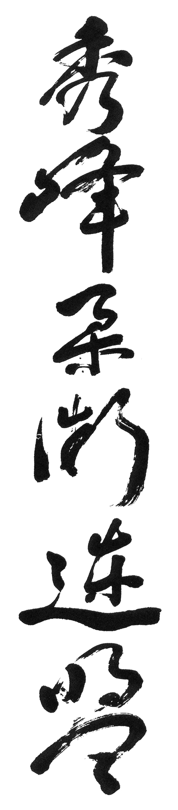
Brown Belt (1st Kyu)

20 Straight Throws

Winding Throws

(A) Inner
(B) Outer

Defence Against Three or More Attackers Indiscriminate

Stomach Throws (5)

Resuscitation Techniques

Nerve and Pressure Points (Various)

Dropping Version of Reverse Body Drop

Shoulder Charge Throw

Defence Against Knife Attacks Using Kicks (Various)

Escape from Both Wrists Held from the Rear (6)

Kicks from the Ground (Various)

Shoulder and Arm Takedown with Dislocations

One Handed Throws (6)

Leg Sweeps Front/Rear (6)

Randori Indiscriminate Kicks and Punches

